Belhus
Cricket Club

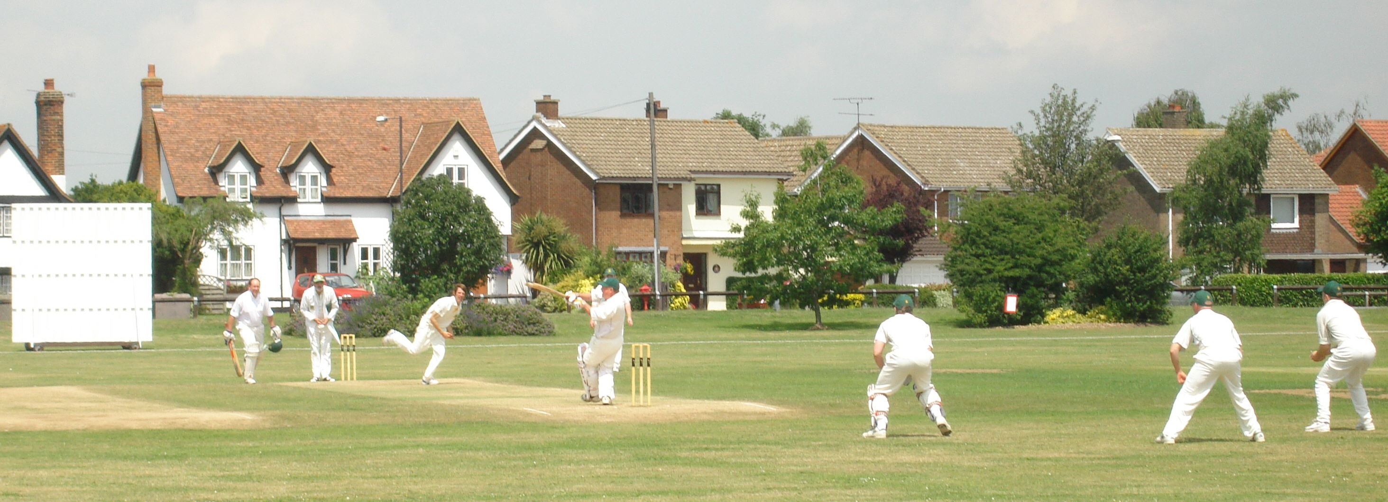

Playing Records

Bowling

Bowling
.........................................

Records and statistics are an integral part of the game of cricket. They remind us of outstanding playing achievements and provide fond memories of team/individual performances as well as an historical record for future generations. First published in 1864, where would the game be without ‘Wisden’ ?

The records that appear on the following pages have been extracted from scorebooks in our possession and/or press reports. These batting records relate only to Senior matches (league, friendly, tour and midweek). They do not include performances in Youth matches. Unfortunately, some scorebooks have been mislaid over the years so if you have any evidential information that may add to/correct these records, perhaps you would kindly let us know. We greatly value and believe it is important to record outstanding performances of colleagues.

Who was it who said that "a cricket club isn't a cricket club without recognising its
historical playing performances"?.

.................................................................................................................................................................

“There can be no summer in this land without cricket”
Sir Neville Cardus

Most Wickets in a Season

142 Bob Garner 1976

134 Don Pegler 1966

133 Don Pegler 1971

127 Don Pegler 1970

115 Don Pegler 1961

111 Don Pegler 1960

106 Don Pegler 1962

106 Don Pegler 1965

102 Don Pegler 1969

101 Richard Harvey 1981

101 John Forrest 1983

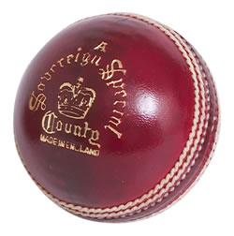

Best Bowling

10 for 18 Albert Braybrook
2nd XI v Heathcotians 24th September 1961

9 for 23 Bert Freeman
1st XI v Marshalls 25th May 1969

9 for 32 David Medlock
1st XI v South Ockendon 5th June 1971

9 for 34 Don Pegler
2nd XI v Swanley 16th May 1971

9 for 15 Bill Taylor
2nd XI v Great Burstead 13th May 1973

9 for 31 Robert Waters
2nd XI v Rettendon 3rd September 1977

9 for 45 Paul Dowsett
2nd XI v Hutton 20th September 1980
9 for 34 Cliff Cansdale
2nd XI v Snaresbrook 19th May 1991

Hat Tricks

Greg Arendse 1st XI v Stanton 26th June 1960(2 wickets) 1st XI v Elmford 9th July 1960 (1 wicket)

Graham Cunliffe 2nd XI v Cranham 3rd June 1962

Keith Davis 1st XI v Becontree 31st August 1969

Bob Young 2nd XI v St Chad’s 21st August 1971

Peter Cline 2nd XI v Rainham 16th July 1972

Mark Davies Under 15s v Essex Taverners 16th July 1975

Bob Clarke 2nd XI v Royal College of Music 30th August 1976

Bob Garner 2nd XI v Conway (4 wickets in 4 balls) 8th May 1977

Bob Garner 2nd XI v Panalpina (4 wickets in 4 balls) 6th June 1977

Richard Harvey 2nd XI v Little Thurrock 12th September 1981

John Lewis Snr 2nd XI v Tilbury 6th June 1982

Jim Robertson 3rd XI v Benfleet 16th July 1983

Andy Armit 2nd XI v Fords 30th July 1983

Mandrake Khan 2nd XI v Becontree 29th July 1985

Gary Plane 2nd XI v Bow Rovers 22nd June 1986

Ritchie Loveridge Under 13s v Eastwood 13th July 1986

Cliff Cansdale 2nd XI v Pitsea 7th August 1993

Mathew Lewis Snr 2nd XI v Britannic Lodge 18th June 1994

Kevin Horsey 2nd XI v South Ockendon Hospital 21st August 1994

John Forrest 2nd XI v Clacton 11th June 1995

Jagjit Johal Under 13s v Wickford 23rd June 1996

Simon Lighten Under 13B v Hornchurch Athletic 11th August 1996

Tony Cobb Under 13s v Chelmsford 10th May 1997

Warren Keeble Under 13A v Pegasus 21st August 1997

Jim Robertson 1st XI v Tillingham 24th August 1997

Jim Banner Midweek XI v Eastwood 9th August 2001

Mason Wren Under 15s v Pegasus & Corringham 10th July 2003

Mason Wren Under 15s v Pegasus & Corringham 25th May 2004

Owen Jefferies Under 13s v Stanford-le-Hope (4 wickets in 4 balls) 20th May 2008

Chris Baker 2nd XI v Ongar 22nd August 2009

Ricki Ellis 2nd XI v Woodford Green 12th June 2010

Ricki Ellis 1st XI v Old Brentwoods 19th June 2010

Joe Dalton Under 11s v Pegasus & Corringham (4 wickets in 4 balls) 10th July 2011

Josh Reynolds Under 13s v Rayleigh 19th May 2013

George Maidment 5th XI v Hainault & Clayhall 10th August 2013

Gary Sanderson 1st XI v Westcliff-on-Sea 21st June 2014

Oliver Plunkett Under 11B v Horndon-on-the-Hill 22nd May 2015

Alexander Winder Under 11B v Benfleet (Age 6 years 356 days) 4th July 2015

Gary Sanderson and Mathew Williams 2nd XI v Harlow 14th May 2016
Aidan Fourie Under 12s v Dunmow 11th June 2017

James Webb Under 11s v Wickford 19th May 2019

Ashir S\aleem 3rd XI v Chelmsford 22nd June 2019

Seth Coelho 5th XI v Chelmsford 13th July 2019

Henry Overy Under 13s v Hadleigh & Thundersley 1st September 2019

Sahan Nanayakkara 1st XI v Brentwood 10th July 2021

Aftab Mohammed 5th XI v Billericay 19th July 2021

Most Opposition Batsmen clean-bowled in an Innings – by an Individual

- Don Pegler
2nd XI v Swanley 16th May 1971

- Mandrake Khan
2nd XI v Becontree 20th July 1985

7 Don Pegler
1st XI v Fairfield 9th May 1964

7 Bert Freeman
1st XI v Marshalls 25th May 1969

7 Richard Waters
1st XI v Abridge 4th May 1985

Most Opposition Batsmen clean-bowled in an Innings – by a Team

10 Pinchin Johnson v 1st XI 1st May 1966

10 Roydon v 2nd XI 13th August 1966

9 Forest Lane Sports v 1st XI 27th August 1967

9 Asians v 1st XI 10th May 1987

9 South Woodham Ferrers v 1st XI 25th June 1995

Best Bowling for Each XI

1st XI 9 for 23 Bert Freeman
v Marshalls 25th May 1969

2nd XI 10 for 18 Albert Braybrook
v Heathcotians 24th September 1961

3rd XI 8 for 22 Billy Winter
v Havering-atte-Bower 16th June 2007

4th XI 7 for 29 Paul Whitlock
v Old Southendian & Southchurch 23rd May 2009

5th XI 7 for 24 George Maidment
v Hornchurch 10th August 2013

Midweek XI 8 for 33 Colin Pennycook
v Walmer 3rd August 1983

Most Overs in an Innings - by a Team

76 1st XI v Stanton 26th June 1960

Most Overs in an Innings - by a Bowler

28 David Medlock
1st XI v Clacton 16th May 1971

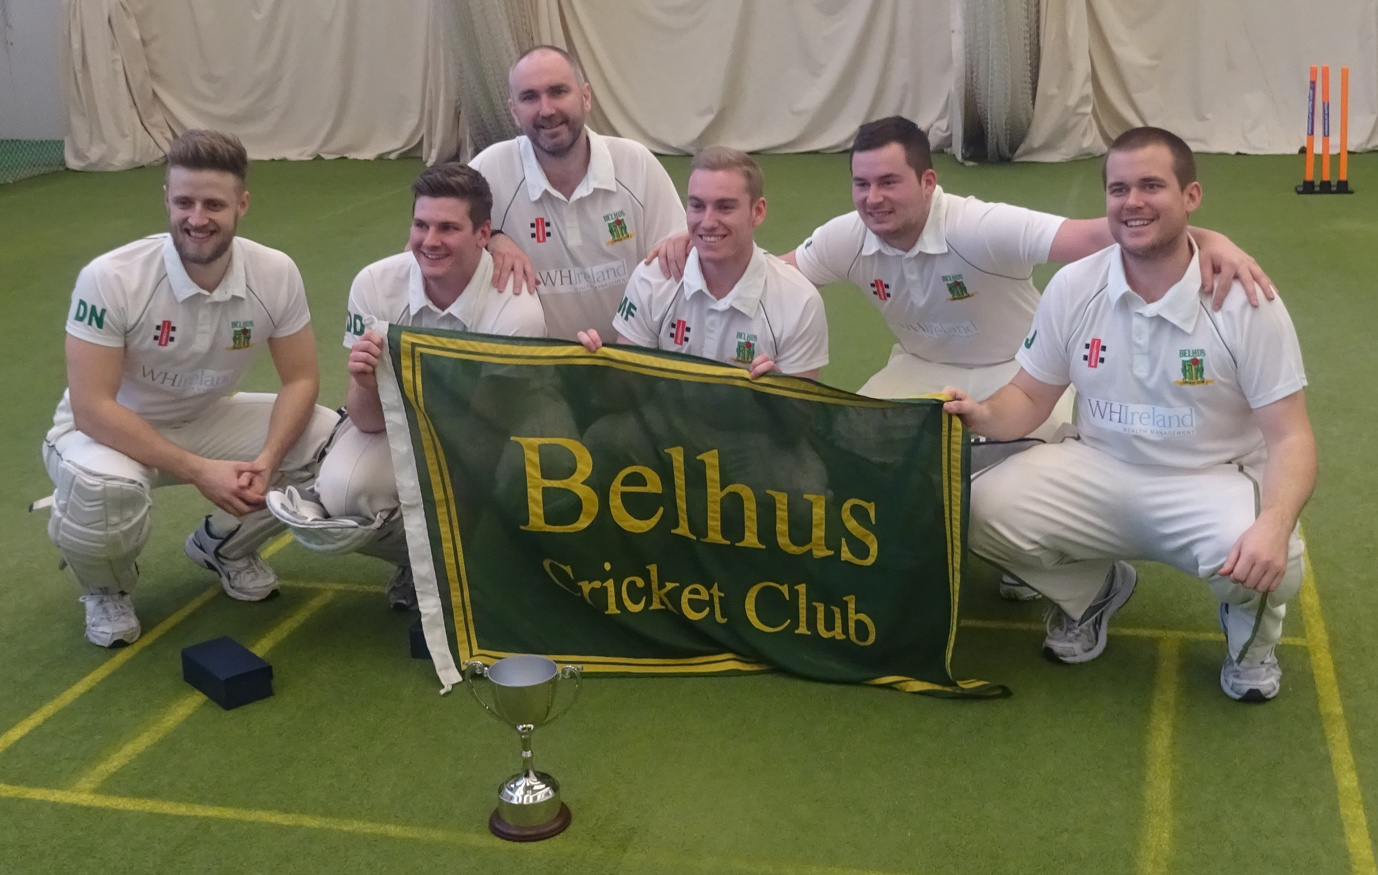
National Indoor Champions 2016

